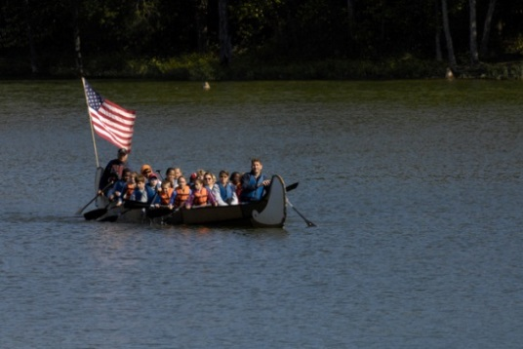
Voyageur Canoes in Louisville, KY
Voyageurs traveled the length and breadth of Canada and Northern United States on a network of lakes and rivers, the great highways of trade and discovery. These early travelers were the backbone of the developing economy; they were the pioneer tractor trailer truck. They used their voyageur canoes to transport trade goods into the wilderness returning each year with a bounty of furs and stories of this great land unfolding before them.
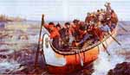
In 1670, René-Robert Cavelier de La Salle made his way from the Great Lakes into the Ohio River Basin and according to his records made it down the Falls of the Ohio, and the future site of Louisville Voyageur canoes were actively used by both sides in the French and Indian Wars and the War of 1812. The Voyageur Canoes you are paddling in are now based at Louisville’s Community Boat house on the upstream end of Waterfront Park and are used for environmental education with a goal of exploring and understanding Louisville’s waterways.
Safety Guidelines: Before you get in the voyageur canoe and experience the thrill and fun that racing brings, read this document so that you understand basic safety rules.

- Life Jackets: Life Jackets must be worn while paddling in the voyageur canoe. There are absolutely NO EXCEPTIONS to this for any reason at any time.

- Boarding: One person at a time boarding, maintaining three points of contact. While in the boat stay seated and have one hip placed firmly against the side of the boat.

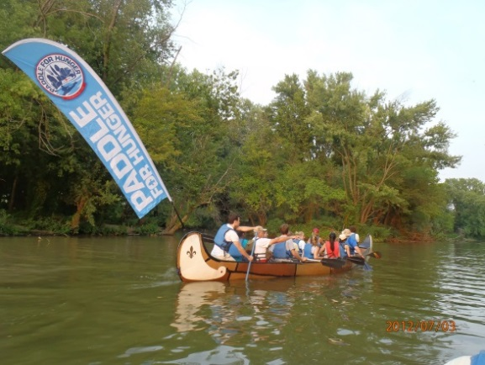
- Capsize or Collision Safety: A capsize or collision rarely occurs, but if it does, Stay Calm and listen to your Captain for direction. Stay With the Boat - until the rescue craft arrives. Till then, you should spread evenly around both sides of the capsized boat holding onto the top edge. Drink Water: Dehydration can happen quickly

Dress appropriately: Comfortable clothes, wear a hat and sunglasses.

Proper sun protection: Sunburn can happen quickly on the water. A hat is advisable on hot days.

Questions: Speak with your Captain

Strategies to make the canoe go faster

Paddle Stroke Technique: To make a voyageur canoe move efficiently through the water, paddling in unison is essential. There are four basic strokes: Forward, Backward, Draw and Hold Water:

Forward Stroke: The most important ingredient to making a voyageur canoe crew work efficiently is timing; the bow paddler sets the pace. TEAM: Together Everyone Achieves More. The paddle should be as vertical; both hands are outside the canoe, right on top of each other. There are 5 parts to the voyageur canoe forward stroke: Check out this video on the Forward Stroke.

- Rotation: The first step is initiating the stroke is rotation. With rotation, the paddler twists their torso from the hips. Imagine showing your back to the shore, or your chest to your bench mate.

- Reach: Rotation is fundamental to a paddler maximizing reach or extension. Reach or extension is achieved by fully extending the bottom or outer shoulder and elbow at the point of maximum rotation. Throughout the extension phase, the top arm should be positioned so that a square catch can be initiated; i.e. the blade will be perpendicular to the surface of the water.

- Pull: The pull phase begins when the blade is fully buried and is initiated with a strong counter rotation of the bottom shoulder and torso. With a straight bottom arm (that you will minimally bend at the elbow towards the end of the stroke), pull the boat past the paddle in a straight line parallel to the direction of travel.

- Exit: The exit phase starts as rotation ends, when the bottom hand reaches the mid-thigh. The paddle should exit quickly and smoothly by rotating the hip forward and lifting the top arm until the bottom edge of the blade just clears the water.

- Recovery: It is important to stay relaxed during the recovery phase of the stroke. Keep a loose bottom wrist and a smooth transition as the paddle returns to the starting position.

Draw Stroke: This stroke is essential for a quick turn. In essence, the draw stroke is the same as the forward stroke, except perpendicular to the Keel of the boat. To turn to the left, the front three paddlers would do a draw stroke on the left and the back three paddlers do a draw stroke on the right. This will force the boat to turn quickly. Check out this video: How to do a Draw Stroke

The Brace: When turning a canoe if paddlers who are not doing to draw stroke or paddling forward should brace the canoe. Basically, one puts the paddle blade on the surface of the water and lean into it. Check out this Video How to do a Low Brace

Hold Water: Holding water stops the canoe. This is a crucial stroke to prevent collisions with another canoe or a dock. Put the paddle in the water vertical and if necessary put some backward pressure on it.

The Bow Paddler: Each canoe will have 10 paddlers, a bow paddler and a captain in the stern. The bow paddler sets the pace for the canoe and also helps steer the boat by doing a draw stroke on either side depending if you want to go to the right or the left.
Have fun and enjoy the river,
Work together, if everyone paddles together the boat goes faster.
Create your one cheer or chant to motivate team paddlers.
Captains do not paddle forward, they only steer the boat with draws, prys, stern rudder, if necessary sweep or back paddle, captains, can certainly encourage the participants to paddle, or to help steer with the front two paddlers doing a draw stoke or pry stokes in the bow. The captains and co captains also should ensure that the boat is trim and stronger paddlers are split between each side of the boat.

